Philippians

Results of Imitating Christ’s Attitude

Joy |  |  | Humility |  | Protection |  | Peace
Chapter 1 |  |  | Chapter 2 |  | Chapter 3 |  | Chapter 4
Joy (5x) |  |  | Joy (7x) |  | Joy (1x) |  | Joy (4x)
Attitude (1x) |  |  | Attitude (7x) |  | Attitude (8x) |  | Attitude (4x)
Suffering |  |  | Submission |  | Salvation |  | Sanctification
Salutation  1:1-2 | Thanks & Prayer  1:3-11 | In Prison Ministry  1:12-30 | Exhorted  2:1-4 | Exemplified  2:5-30 | From Legalism  3:1-16 | From Indulgence  3:17-21 | With People  4:1-3 | With God  4:4-9 | Always  4:10-20  –  Greetings  4:21-23
Rome

Early Spring AD 62 (first Roman imprisonment)

Key Word: Attitude

Key Verse: “Your attitude should be the same as that of Christ Jesus”
(Philippians 2:5).

Summary Statement: The results of imitating Christ’s resurrection attitude are joy, humility, peace, and protection from false teachers and disunity in the church.

Application: How do you need to show a more Christ-like attitude during difficulty?

Note: Words for “joy” total 17 times in the letter but words for “attitude” total 20 times.
Philippians

Introduction

I. Title: The Greek for Philippians (Pro.j Filipphsi,ouj To the Philippians) follows the standard practice of naming the Pauline Epistles after their recipients.

II. Authorship

A. External Evidence: Scholars of nearly all persuasions believe Paul wrote Philippians. The only exception is perhaps F. Baur of the radical 19th century German critics.

B. Internal Evidence: Philippians claims to be written by Paul (1:1). This is confirmed in the references to his companion Timothy (1:1; cf. Acts 16) and the description the author gives of himself (3:4-6).

III. Circumstances

A. Date: Paul notes his chains (1:14) in Rome (palace guard 1:13), which places the letter in his first Roman imprisonment (AD 60-62). Philippians probably was the last of the four prison epistles since Ephesians lacks mention of any expected release, and Colossians and Philemon were written at about the same time as Ephesians or shortly afterwards (AD 60-61). Therefore, the best date for Philippians is early spring AD 62. Paul wrote just before his release in answer to the church's prayers (1:19).

B. Origin/Recipients: The palace guard (1:13) and Caesar's household (4:22) show that Paul wrote during his Roman imprisonment (not his captivity in Ephesus or Caesarea). Therefore, he wrote from Rome and sent the letter to the colony of Philippi (1:1b) by Epaphroditus (2:25-30).

C. Occasion: Paul’s “Macedonian Call” on his second missionary journey led him to plant the church at Philippi (Aug-Oct AD 50). Lydia, others, and the Philippian jailer responded to the gospel, but then government officials asked Paul and Silas to leave (Acts 16). Paul returned to the city six years later, but probably only for a few days (between June-Nov AD 56; Acts 20:1, 6). He wrote this thank you letter to the church six years later (AD 62) after the church had sent Epaphroditus with a gift (4:18). Epaphroditus almost died of an illness, but when he recovered Paul sent him back to the Philippians with the letter (2:25-30). Paul’s immediate motive for writing was to express his affection and thanks for the church's generosity (other purposes are listed in the “Argument” section below). Yet another key purpose was to encourage perseverance (1:27-28; 2:12; 3:13-15; 4:1) against Judaizers who sought to require obedience to the Mosaic law (1:27-28; 3:2-4, 17-19; cf. Acts 15:1-6; Gal. 1:6-9; 2:1-16; 3:1-5; 5:7-10; 6:12-13). The way the Philippians could persevere was to imitate Christ’s attitude, so Paul emphasized the results of this type of resurrection spirit.

IV. Characteristics

A. Philippians is not a systematic treatise of formal doctrine, but it contains the most significant christological passage in the Pauline epistles (2:5-11), cited as an example of humility. This passage is often called the kenosis passage since it refers to Christ's emptying (Gr. keno,w “to empty”) his rights (not deity) as God. These seven verses provide profound insights into his preexistence, incarnation, humiliation, and exaltation (TTTB, 408).

B. The authorship has rarely been debated for Philippians, but the unity has been strongly challenged. Some suggest several interpolations by Paul at different times. Particularly at issue are: (1) a sudden change in tone from affection to warning and from the posture of fellow worker to an assertion of authority (3:1a contrasts 3:1b) and (2) the so-called poetic hymn in the midst of prose (2:6-11). The first issue is not significant since Paul certainly could change disposition as he writes and secondly, the insertion of a well-known or even Pauline “hymn” does not affect the inspiration of the letter.
C. Central Theme: Philippians is one of the most studied biblical books, resulting in differing ideas on the theme. Here are some examples of the central idea (from least likely to most likely):

1. Living the Christian life (Robert P. Lightner, “Philippians,” BKC, 2:647) is offered as a theme but is too general since all NT books exhort Christian living.

2. Pastoral: Paul's warmth here is unmatched by any other epistle. “He pours out his heart [to these] whom he prizes highly and loves profoundly” (Hendriksen, NTC, 39; cf. Lightfoot, 66; Martin, NCBC, vii). After all, this was the first church ever in Europe. But this theme does not account for the exhortations and doctrinal content.

3. Joy: The most popular theme for Philippians is that believers can rejoice despite their circumstances due to Christ (Benware, 222; Wiersbe, Be Joyful; Briscoe, Bound for Joy; William D. Lawrence, “Overcoming Under the Circumstances,” DTS Video Series, 1984, 4). Joy during trials is certainly an emphasis since the words “joy” or “rejoice” or “glad” appear 17 times in this four-chapter book (1:4, 18 [2x], 25, 26; 2:2, 17 [2x], 18 [2x], 28, 29; 3:1; 4:1, 4a, 4b, 10). Yet this theme downplays its doctrinal elements too much.

4. The Person of Christ (Alec Motyer, The Message of Philippians, BST, 22-23) is prominent as his name is noted 70 times or more. The following lists every occurrence of “Christ,” “Jesus,” “Lord,” or pronouns referring to Him in the book:

Characteristics | Chapter 1 | Chapter 2 | Chapter 3 | Chapter 4
Deity (God) |  | 2:6
Pre-eminent (Lord) | 1:2, 20 | 2:9-11 | 3:20-21
Returning in Power | 1:6, 10 | 2:10, 16 | 3:20-21 | 4:5
Sacrificial (Cross) | 1:29 | 2:8 | 3:18
Savior |  |  | 3:20
Glorified Body (Resurrected) |  |  | 3:10, 21
Incarnation (man) |  | 2:6-8
Humble |  | 2:6-8
Obedient |  | 2:8
Selfless Interests (Servant) |  | 2:6, 21
Has a Ministry Plan |  | 2:21, 30
Provider of Needs |  |  |  | 4:19
Helper via the Spirit | 1:19
Answers Prayer | 1:19
Gives Faith to Believe | 1:29
Gives Privilege of Service | 1:1, 14-18, 22
Gives Ability to Glorify Him |  |  | 3:3
Gives Affection for Others | 1:8 | 2:29
Gives Righteousness (Saints) | 1:1, 10-11 |  | 3:9 | 4:21
Gives Encouragement |  | 2:19
Gives Knowledge of Himself |  |  | 3:8, 10
Gives Glory to God | 1:11
Gives Grace | 1:2 |  |  | 4:23
Gives Comfort to Us |  | 2:1
Gives Comfort for Others |  | 2:1
Gives Purpose for Ministry |  | 2:16
Gives Life | 1:21
Gives Ability to Do Everything |  |  |  | 4:13
Gives Joy (Contentment) | 1:18, 26 | 2:29 | 3:1 | 4:4, 10-13
Gives Confidence (Ability to Stand) | 1:13-14 | 2:19, 24 |  | 4:1, 19
Gives Peace | 1:2 |  |  | 4:2, 7
Gives Suffering | 1:13, 29 |  | 3:10
Gives Rewards | 1:21, 23 |  | 3:7-8, 14
Gives Humility |  | 2:5
Gives Unity | 1:15-17 | 2:1-2 |  | 4:21-22
Gives New Bodies (Resurrection) |  |  | 3:11, 21
Gives Christlikeness (Exalts Himself in Us) | 1:20, 27 | 2:5 | 3:10-14

5. Multipurpose (TTTB, 408): Paul had many purposes in composing this epistle to the Philippians. He expresses affection for them (1:7), thanks them for their gift (1:5, 7; 4:10-19), updates them on his missionary work in prison (1:12f.), encourages them in their growth (1:27f.), corrects a problem of disunity in the church (2:1-4, 14; 4:2), encourages them of Epaphroditus' recovery (2:25f.), warns of false teaching (1:28)—especially legalism (3:2-4) and libertinism/ antinomianism (3:17-19)—and exhorts them to express joy in their trials as he had in his own sufferings (3:1; 4:4).

6. Imitating the Attitude of Christ: While Philippians emphasizes the person of Christ, the application of this truth is the focus of the book. Having Christ’s attitude (or mind) appears to be the most all-encompassing purpose, with 2:5-11 forming the heart of the book (Moisés Silva, WEC, 19-20; cf. see “Argument” below). This theme goes deeper than joy (or any other positive characteristic in the book) since it explains how one can experience these qualities during difficulty (cf. p. 186k).

Argument

As good as the above purposes are, none sums up the book as a whole except the last one—to have the mind or attitude of Christ. Clearly Christ is the main subject as his name appears 70 times, but some key verbs convey the idea of imitating his thinking, attitude, or mind appear twenty or more times (frone,w “think, form opinion, set one's mind on, be minded, or disposed” [BAGD] 1:7; 2:2a, 2b, 5; 3:15a, 15b, 16 [Byz.], 19; 4:2, 10a, 10b; h`ge,omai “think, consider, regard, lead, guide” [BAGD] 2:3, 6, 25; 3:7, 8a, 8b; skope,w “notice, consider” 2:4; 3:17; logi,zomai “reckon, consider” 3:13; 4:8). This is supported with many “knowledge” terms (esp. 1:9-11; 3:8-10) “which include, but are not restricted to, purely intellectual concerns” (Silva, 20).

Therefore, the concept of imitating Christ's attitude in difficulty appears more times (over 20) than the theme of rejoicing (17 times) and should be given at least as much weight (3:10). Each chapter bears out this emphasis since having Christ's attitude produces: joy in adversity (Phil 1), humility leading to unity (Phil 2), protection from legalistic or libertine teaching (Phil 3), and peace with God and man in all circumstances (Phil 4). Paul wrote the Philippians to let them know that “as a man thinks, so is he” (Prov 23:7) and the best thinkers do so with Christ's attitude. Paul states the key verse in this respect in Philippians 2:5, “Your attitude should be the same as that of Christ Jesus” (NIV), which begins the heart of the book (2:5-11). A related concept is that of mimicking Paul (3:17; 4:9).

Synthesis

Results of imitating Christ’s attitude

1 Joy
1:1-2 Salutation
1:3-11 Thanksgiving/prayer
1:12-30 Joy in prison ministry

2 Humility
2:1-4 Exhorted
2:5-30 Exemplified in…
2:5-11 Christ
2:12-18 Paul
2:19-24 Timothy
2:25-30 Epaphroditus

3 Protection
3:1-16 From Legalists
3:1-3 Warning against legalists
3:4-6 Paul's former confidence in the flesh
3:7-16 Paul's present pursuit of Christlikeness
3:17-21 From Libertines
3:17-19 Warning against libertines
3:20-21 Christ's power
4 Peace
4:1-3 Peace between two women
4:4-9 Peace with God
4:10-20 Peace in all circumstances
4:21-23 Affectionate greetings

Outline

Summary Statement for the Book
The results of imitating Christ’s resurrection attitude are joy, humility, peace, and protection from false teachers and disunity in the church.

Imitating Christ’s attitude brings joy like Paul had in prison by seeing the gospel advance, so the Philippians should have while fighting their enemies (Phil 1).

Paul's introduces himself and Timothy warmly to begin on an affectionate note (1:1-2).

Authors: Paul calls himself and Timothy servants to set a tone of affection (1:1a).

Recipients: The Philippian congregation and leaders received its holiness in Christ (1:1b).

Salutation: The Father and Son are identified as the Source of favor and harmony (1:2).

Paul gives thanks and prays for them to have Christ's attitude of righteousness (1:3-11).

Paul thanks them for partnering in their giving with the promise of God’s blessing (1:3-8).

Paul prays for their love to grow in both knowledge and virtue until the rapture (1:9-11).

Paul rejoices that his captivity spread the gospel so they will show joy in their trials (1:12-30).

Paul rejoices that guards trust Jesus so the church will rejoice in its suffering (1:12-18a).

Prison helped Paul preach the gospel even farther rather than hindering it (1:12-14).

Paul even rejoiced that some selfishly preached the gospel (1:15-18a).

Paul rejoices whether executed or freed since both have their advantages (1:18b-26)!

Persecutors | Paul
“Aha! You like to share about Jesus? I’ll imprison you!” | “Good! This will give me more time to pray, write letters to the churches, and share Christ with soldiers guarding me.”
“Well, then, I’ll torture you!” | “Thank you, for in this way I can participate in the sufferings of my Master, Jesus.”
“Oh yeah? Then I’ll kill you!” | “This is the best option yet, for then you will usher me into his presence!”

They must contend against their persecutors by obeying Jesus in unity and joy (1:27-30).

Imitating Christ’s attitude brings humility modeled in Christ, Paul, Timothy, and Epaphroditus to exhort the church to unity (Phil 2).

Each believer should work towards unity through a humble concern for one another to prevent church divisions (2:1-4; see p. 186d).

Four humble individuals exemplify selfless concern to lead to the unity of the body (2:5-30).

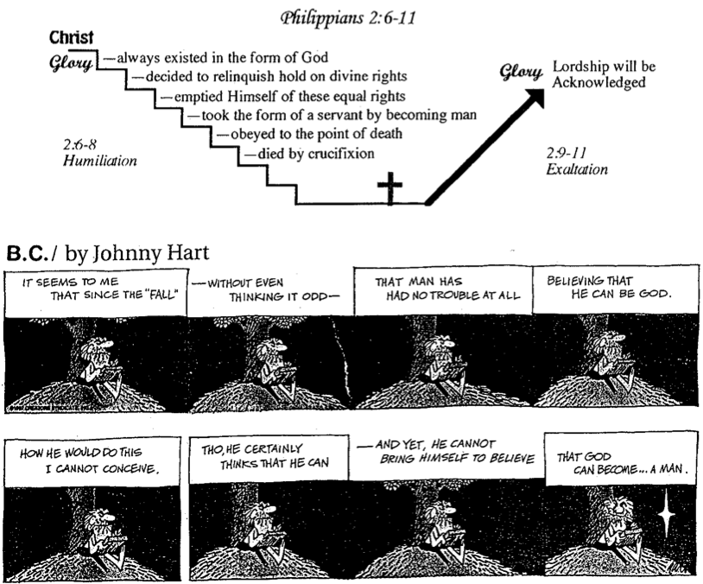
Christ modeled humility as our best example since he refused his rights as God (2:5-11).

Paul modeled humility in selfless service so they should stop their complaining (2:12-18; see pp. 186e-f).).

Timothy modeled humility so Paul planned to send him to the church (2:19-24).

Epaphroditus modeled humility in his concern for the church (2:25-30).

Imitating Christ’s attitude brings protection from the extremes of law and liberty to give them balance instead of self-righteousness or excess (Phil 3).

Christlikeness guards us from legalism by denying our flesh (3:1-16).

Paul warns the church against legalists (3:1-3).

Paul used to have confidence in his works and pedigree (3:4-6; cf. p. 186h).

Paul renounces his self-righteousness by seeking Christlikeness above all (3:7-16).

All his gains are garbage compared to knowing Christ (3:7-11; see p. 186h).

The church should seek Christlikeness like Paul (3:12-16).

*Have you renounced personal accomplishments to pursue Christlikeness (see p. 186i)?

Christlikeness protects us from libertines who indulge their flesh (3:17-21).

Libertines live for today by indulging their flesh, so avoid them (3:17-19; see p. 186j).

Believers live for tomorrow by anticipating their glorified bodies (3:20-21).

Imitating Christ’s attitude brings peace with God and man at all times through Christ's strength for unity and contentment (Phil 4).

Paul pleads for peace between two arguing women (4:1-3).

Paul promises peace with God by following some simple principles (4:4-9).

Rejoice (4:4).

Be gentle with others (4:5).

Pray in all circumstances (4:6-7).

Think about praiseworthy things (4:8-9).

Paul rejoices with peace in all circumstances (4:10-20).

Paul closes his letter with affectionate greetings to show his deep care for them (4:21-23).

Philippi in the Time of Paul
Bible Visual Resource Book, 247

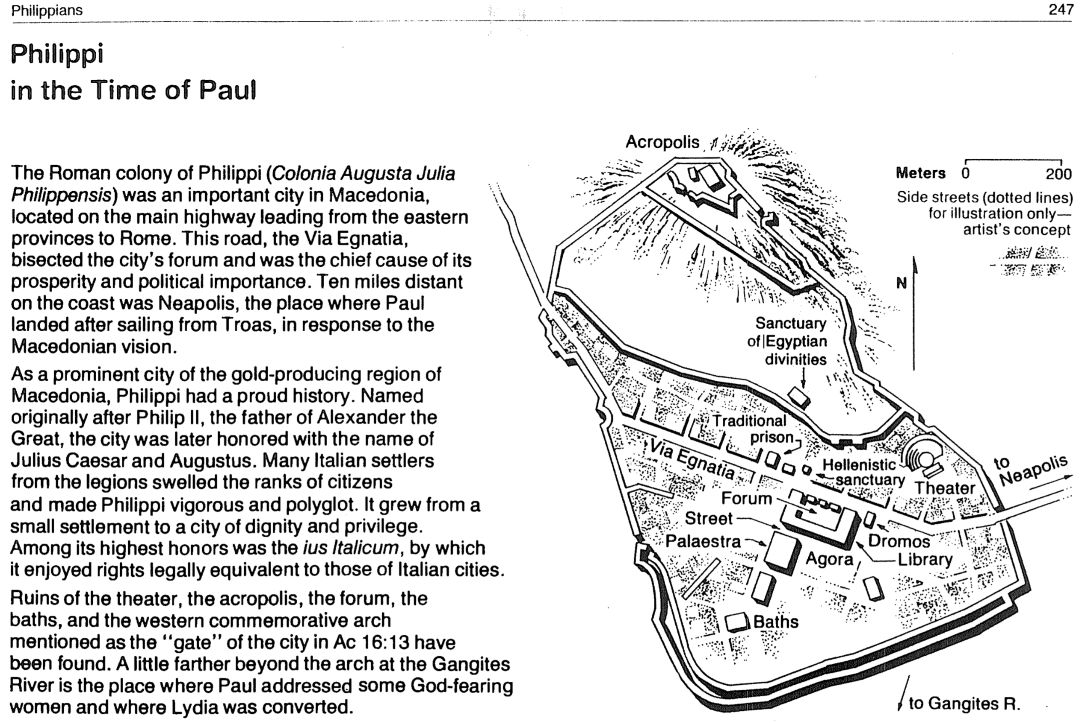

Happiness verses Joy

Happiness | Joy
External | Internal
Dependent on circumstances | Independent of circumstances
Emotional response | Act of the will
Having what  you want | Wanting what  you have
Euphoria | Contentment
Effect | Cause
Result | Foundation
Inconsistent | Consistent
Temporary | Eternal

Two Ways to Relate to Others
Philippians 2:1-4

Selfish | Selfless
Produces grumbling  (2:14) | Produces joy  (2:2a)
Leads to division  (4:2) | Leads to unity  (2:2b)
Proud  (2:3a) | Humble  (2:3b)
Considers self better than others  (2:3a) | Considers others better than self  (2:3b)
Looks out for self  (2:4a) | Looks out for others  (2:4b)
Imitates Satan | Imitates Christ  (2:5)

Results of a Bad Attitude
Philippians 2:14-16

Those who invested in us will wish they had invested in others
We won’t be blameless and innocent
We won’t stand out with a positive impact
If we complain and argue
Results of a Good Attitude
Philippians 2:14-16

Those who invested in us will rejoice that their efforts had been worth it
If we do everything without complaining and arguing
We will be blameless and innocent, children of God above reproach
We will shine like stars in the universe
Balance in the Christian Life

Legalism | A Godly Balance | Libertinism
Phil. 3:1-3 | Phil. 3:4-16 | Phil. 3:17-20
Legal = Law Only | Standards and Liberty | Liberty = No Law
Excessive Rules | Only Biblical Rules | License for Everything
Actions are Everything | Actions are Something | Actions are Unimportant
Highly Structured | Some Structure | No Structure
Pharisee-like | Christlike | Glutton-like
“god” is their Traditions | God is Christ | “god” is their Stomach
Starves the Flesh | Controls the Flesh | Indulges the Flesh
Claim of Perfectionism | In Process (3:12-13) | Practice of Fatalism
Think they’ve Arrived | Know they Haven’t | Don’t Care if they Do
Confidence  in Flesh (3:3) | Confidence  in Christ (3:7) | Confidence  in Shame (3:19c)
Righteousness  from the Law (3:9a) | Righteousness  by Faith (3:9b) | Righteousness  Not Pursued (3:19d)
No Movies | Wholesome Movies | All Movies
No TV | Wholesome TV | All TV
No Music | Wholesome Music | All Music
No Wine for Merit | No Wine/Moderation | Drunkenness
Unclean Foods | Moderation | Gluttony
“Christian Sabbath” | Rest | Frivolity
Celibacy Required | Celibacy for Ministry | Sexual Immorality
Salvation can be Lost | Eternal Security | Salvation can’t be Gained

Paul’s Pedigree (Phil. 3:4-6)
Circumcised the eighth day | This sign of participation in the Abrahamic Covenant separated Paul from pagans and was performed on him the exact day the OT prescribed (Gen. 17:11-12)
Of the people of Israel | Paul was a pure-blooded member of this race chosen by God himself (not even a proselyte, who was often viewed as “second class”)
Of the tribe of Benjamin | This tribe was one of the smallest, yet it boasted Israel’s first king (Saul)–so Paul was not from a disreputable tribe like Dan, Reuben, etc.
A Hebrew of Hebrews | Paul did not adopt Greek ways even though he grew up in a Greek city (Tarsus)
In regard to the law, a Pharisee | This sect adhered more strictly to the Mosaic law than any sect in mainstream society
As for zeal, persecuting the church | Even most Pharisees did not actively seek to do away with Messianic believers
As for legalistic righteousness, faultless | Paul followed all 613 Pharisaical laws without exception

Excrement for Christ
Philippians 3:7-8

Paul considered his life’s best accomplishments mere “dung” (KJV) compared to knowing Christ. Which of the following items are potential sources of pride in your own life?

Personal
Occupational position/title
Income level
Power
Education/Degree(s)
Other

Social
Social position
Friends
Spouse
House
Car
Neighborhood
Country club
Golf/sports
Children
Other

Spiritual
Church position/title
Tithes, offerings, gifts
Church membership
Ministry experience or giftedness
Bible knowledge
Humility
Other

Physical
Personal Appearance
Strength
Health
Abilities
Other

Is your attitude toward these things like Paul’s? Are they “rubbish” to you?

Modern License
Philippians 3:18-19

Text | Interpretation | Mormons | Holy Laughter
Live as enemies of the cross of Christ | They oppose salvation by faith | Salvation by works | Do not preach the cross
Their destiny is destruction | They are unsaved | Claim that all are saved but are not even saved themselves | Claim to be Christians but if so, why don’t they preach Christ?
Their god is their stomach | Their real goal is pleasure | Goal is to be a god to have sex with as many celestial wives as possible | Goal is to feel good
Their glory is in their shame | They’re proud about things that they should be ashamed of | Temple polygamy is the highest goal | The spiritual heights is to laugh uncontrollably and cluck like a chicken
Their mind is on earthly things | They have  “here-and-now” priorities | “Become a god for ego and sex” | “Don’t use your mind and you will feel great!”

Imitating Christ

Mimicking Christ is one of the most practical suggestions of how to live the Christian life. If each of us could simply ask, “What would Jesus do?” in a given situation, and then actually do it, then our behaviour would radically change for the better.

This challenge is presented in Charles M. Sheldon’s book, In His Steps, written in 1896—over 100 years ago but still in print (Copyright: Chosen Books, 1984; Grand Rapids: Kregel, 1989; Grand Rapids: Spire [Baker], 1994; Uhrichsville, OH: Barbour, 2002. 251 pp.). Due to a copyright error, sixteen publishers began publishing it in the US alone and soon it was printed in 45 countries so that a conservative estimate is 22 million copies in circulation—the world’s record next to the Scriptures! This fiction depicts what happens when a small group of Christians commit themselves to live as Jesus would for an entire year.

Imitating Jesus is not only the theme of the book of Philippians (2:5). Throughout the New Testament we are exhorted to imitate Christ…

In His Character
“For those God foreknew he also predestined to be conformed to the likeness of his Son” (Rom. 8:29)

In His Joyful Suffering
“You became imitators of us and the Lord; in spite of severe suffering, you welcomed the message with the joy of the Holy Spirit” (1 Thess. 1:6)

In His Maturity
“until we all reach unity in the faith and in the knowledge of the Son of God and become mature, attaining to the whole measure of the stature of Christ” (Eph. 4:13)

In His Patience
“But for that very reason I was shown mercy so that in me, the worst of sinners, Christ Jesus might display his unlimited patience as an example for those who would believe and receive eternal life” (1 Tim. 1:16)

In His Perfection
“We proclaim Him, admonishing and teaching everyone with all wisdom, so that we may present everyone perfect in Christ” (Col. 1:28; Matt. 6:33)

In His Submission to Unjust Suffering
“To this you were called, because Christ suffered for you, leaving you an example, that you should follow in His steps” (1 Pet. 2:21)

In Everything
“He must become greater. I must become less important” (John 3:30)

“…I am in the pains of childbirth until Christ is formed in you” (Gal. 4:19)

“Whoever claims to live in him must walk as Jesus did” (1 John 2:6)

